

AMERICAN INTERNATIONAL
UNIVERSITY-BANGLADESH

COMPUTER GRAPHICS – PROJECT
Project Title: "A Day in the Life of a Panda: Interactive 2D Animation System"

Course Name | Computer Graphics
Section | I
Course Tutor | Dipta Justin Gomes

Members
Name | ID
Sumaiya Beantey Alam Raisha | 23-50086-1
Sadia Khandaker Moumita | 23-52278-2
GROUP MEMBERS

Table of Content:
Content List | Page No
Introduction | 03
Proposal | 04
List of Objects | 05
Functions to Represent the Objects | 06 - 08
Interactive Functions | 09
Task Assignment and Codes of Functions | 10
Screenshot of the project | 11-14
Code availability | 15
Future Work | 15
Conclusion | 16

Introduction
OpenGL (Open Graphics Library) is a cross-language, cross-platform application programming interface (API) for rendering 2D and 3D vector graphics. It provides developers with powerful tools to create engaging visual experiences ranging from simple 2D scenes to complex animated environments.
GLUT (OpenGL Utility Toolkit) is a library that simplifies OpenGL program development by handling window management, input processing, and basic event handling. This toolkit is particularly useful for creating educational and demonstration graphics applications.
This project demonstrates the use of OpenGL and GLUT to create an interactive 2D animation system featuring a panda character in four different lifestyle scenarios. The project implements fundamental computer graphics concepts including:
- 2D primitive rendering (circles, polygons, lines)
- Color manipulation using RGB values
- Animation through transformation matrices
- User interaction via keyboard input
- Scene management and state transitions
- Smooth animation timing and updates
The application showcases a panda engaged in natural behaviors: eating bamboo, drinking by a river, sleeping in a cave, and playfully rolling on hills. Each scene features unique environmental elements and animations that bring the panda's world to life.

Proposal

Project Overview
Our project, "A Day in the Life of a Panda: Interactive 2D Animation System", uses OpenGL to create an immersive visual storytelling experience featuring a panda character through different times of day and activities.

Key Features
The application presents four distinct animated scenes:
- Scene 1: Eating Bamboo (Daytime)
  - Panda sitting and eating bamboo with animated hand and mouth movements
  - Bright daytime sky with animated sun and clouds
  - Bamboo forest environment with grass details
- Scene 2: By the River (Afternoon)
  - Panda sitting by a flowing river
  - Animated water with wave effects and bubbles
  - Head-turning animation as the panda observes surroundings
  - Rocks, plants, and natural riverside elements
- Scene 3: Sleeping in Cave (Night)
  - Nighttime scene with moon and twinkling stars
  - Panda sleeping with gentle breathing animation
  - Animated fireflies floating around
  - Cave environment with "Zzz" sleep indicators
- Scene 4: Rolling on Hills (Daytime)
  - Panda rolling playfully across hills
  - Butterflies with flapping wing animations
  - Colorful flowers scattered across the landscape
  - Motion lines to indicate movement
  - Pause/resume functionality

Interactive Controls
- Press '1' - Switch to Scene 1 (Eating Bamboo)
- Press '2' - Switch to Scene 2 (By the River)
- Press '3' - Switch to Scene 3 (Sleeping in Cave)
- Press '4' - Switch to Scene 4 (Rolling on Hills)
- Press SPACE - Start/Pause rolling animation (Scene 4 only) - Panda rolls toward bamboo forest!
- Press ESC - Exit application

LIST OF OBJECTS

Environmental Objects
Sky
Night Sky
Sun
Moon
Clouds
Stars
Ground
Night Ground
Hills
Natural Elements
Bamboo Stalks
Night Bamboo
River
Cave

Animated Characters
Panda (Scene 1)
Panda (Scene 2)
Panda (Scene 3)
Panda (Scene 4)
Bamboo Stick
Fireflies
Butterflies
Visual Effects
Shadow
Sleep "Zzz"
Motion Lines

Functions to Represent The Objects

Scene Management Functions

Function | ID | Purpose
display() | 2001 | Main display function - renders current scene
displayScene1() | 2002 | Render Scene 1 (Eating)
displayScene2() | 2003 | Render Scene 2 (River)
displayScene3() | 2004 | Render Scene 3 (Sleeping)
displayScene4() | 2005 | Render Scene 4 (Rolling)
init() | 2006 | Initialize OpenGL settings
initAnimations() | 2007 | Initialize animation variables

Environment Drawing Functions

Function | ID | Purpose
drawSky1() | 2008 | Day sky gradient (Scene 1)
drawSky2() | 2009 | Afternoon sky (Scene 2)
drawNightSky() | 2010 | Night sky gradient (Scene 3)
drawSky4() | 2011 | Day sky (Scene 4)
drawSun1() | 2012 | Sun with rays (Scene 1)
drawSun2() | 2013 | Sun with rays (Scene 2)
drawSun4() | 2014 | Sun with rays (Scene 4)
drawMoon() | 2015 | Moon with glow effect
drawClouds1() | 2016 | Animated clouds (Scene 1)
drawClouds2() | 2017 | Animated clouds (Scene 2)
drawClouds4() | 2018 | Animated clouds (Scene 4)
drawStars() | 2019 | Twinkling stars
drawGround1() | 2020 | Grass ground (Scene 1)
drawGround2() | 2021 | Grass ground (Scene 2)
drawNightGround() | 2022 | Dark grass (Scene 3)
drawHills() | 2023 | Rolling hills (Scene 4)
Natural Element Functions

Function | ID | Purpose
drawBamboo() | 2024 | Bamboo stalk with nodes (day)
drawNightBamboo() | 2025 | Darker bamboo for night scene
drawCave() | 2029 | Cave entrance

Panda Drawing Functions

Function | ID | Purpose
drawPanda1() | 2031 | Panda eating bamboo
drawPanda2() | 2032 | Panda by river
drawSleepingPanda() | 2033 | Sleeping panda
drawRollingPanda() | 2034 | Rolling panda
drawBambooStick() | 2035 | Bamboo being held

Effect Functions

Function | ID | Purpose
drawCircle() | 2036 | Helper to draw filled circles
drawFireflies() | 2037 | Animated fireflies
drawButterfly() | 2038 | Butterfly with wings
drawSleepingZzz() | 2039 | "Zzz" sleep indicator
drawMotionLines() | 2040 | Speed/motion lines

Interactive Functions

Interactive Functions | Interaction | ID
Updatecar1 | void updatecar2 (int value) | 1001
Updatecar2 | void updatecar2(int value) | 1002
Updatecar2 | void updatecar2(int value) | 1003
Updateclouds | void updatecloud(int value) | 1004
Updatecloud1 | void updatecloud1(int value) | 1005
UpdateCloudsN | void updatecloudsN(int value) | 1006
Updatesound | void updatesound(int value) | 1007
updatetrain | void updatetrain(int value) | 1008
updatesun | void updatesun(int value) | 1009
updaterain | void updaterain(int value) | 1010
Updateboat | void updateboat(int value) | 1011
updatewinwheell | void updatewinwheell(int value) | 1012
Updatewinfan2(int value) | void updatewinfan2(int value) | 1013

Task Assignment and Codes of Functions
Member-1 | Member-2 | TOTAL
50% | 50% | 100%
Name  ID | Contribution in Project
Member-1  Sadia Khandaker Moumita  23-52278-2 | drawSky1();  drawSky1();  drawSun1() ;  drawClouds1();  drawGround1();  drawBamboo();  drawPanda1();  drawBambooStick();  updateScene1();  drawSky2();  drawSun2();  drawClouds2();  drawRiver();  drawGround2();  drawPanda2();  updateScene2();
Member-2  Sumaiya Beantey Alam Raisha  23-50086-1 | drawNightSky();  drawMoon();  drawStars();  drawFireflies();  drawNightGround();  drawNightBamboo();  drawCave();  drawSleepingPanda();  drawSleepingZzz();  updateScene3();  drawSky4();  drawSun4();  drawClouds4();  drawHills();  drawButterfly();  drawRollingPanda();  drawMotionLines();  updateScene4()

OUTPUT

Scene 1: Eating Bamboo (Day View)
Description: The panda sits peacefully in a bamboo forest during a sunny day. The panda's hand moves rhythmically to its mouth, simulating eating behavior. Bamboo stalks surround the panda, and white clouds drift lazily across the bright blue sky.
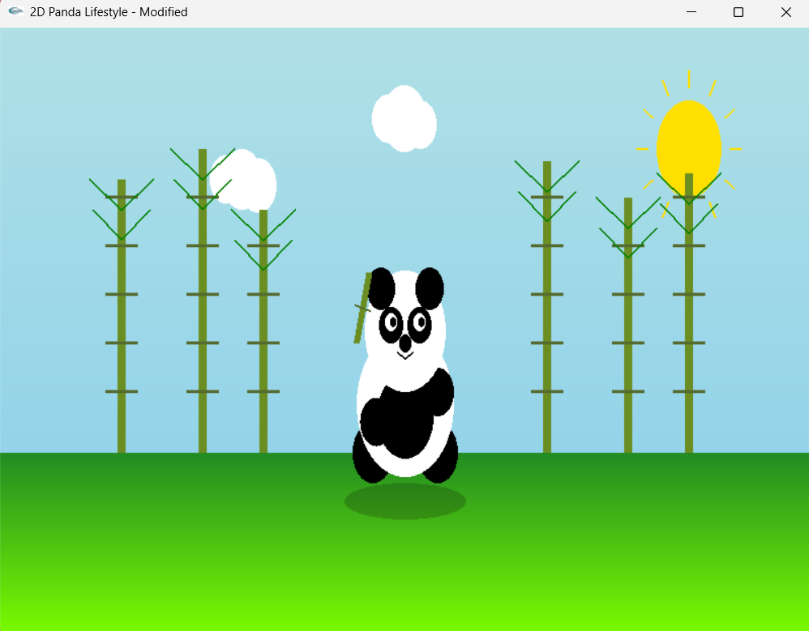

Scene 2: By the River (Afternoon View)
Description: The panda relaxes by a flowing river in the afternoon, surrounded by a bamboo forest. Its head turns from side to side, observing the peaceful surroundings.

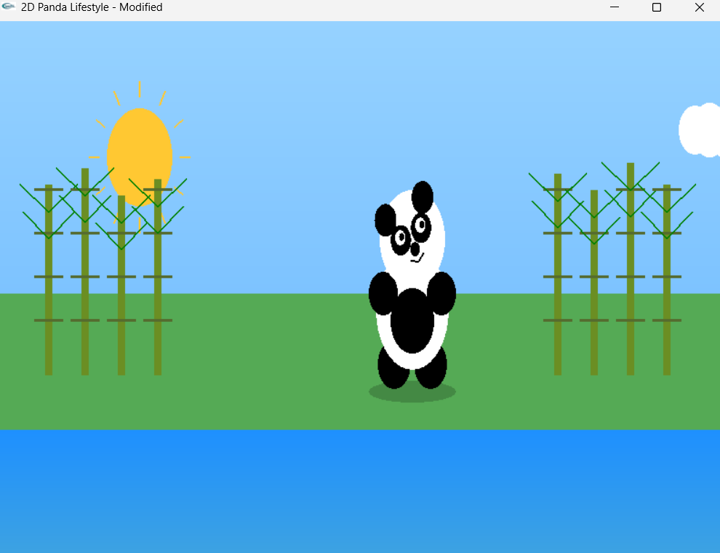
Scene 3: Sleeping in Cave (Night View)
Description: Night has fallen, and the panda sleeps soundly inside a dark cave. The moon glows softly in the sky, stars twinkle overhead, and fireflies dance through the air with their gentle luminescence. The panda's body rises and falls with breathing animation. A dark bamboo forest surrounds the cave.
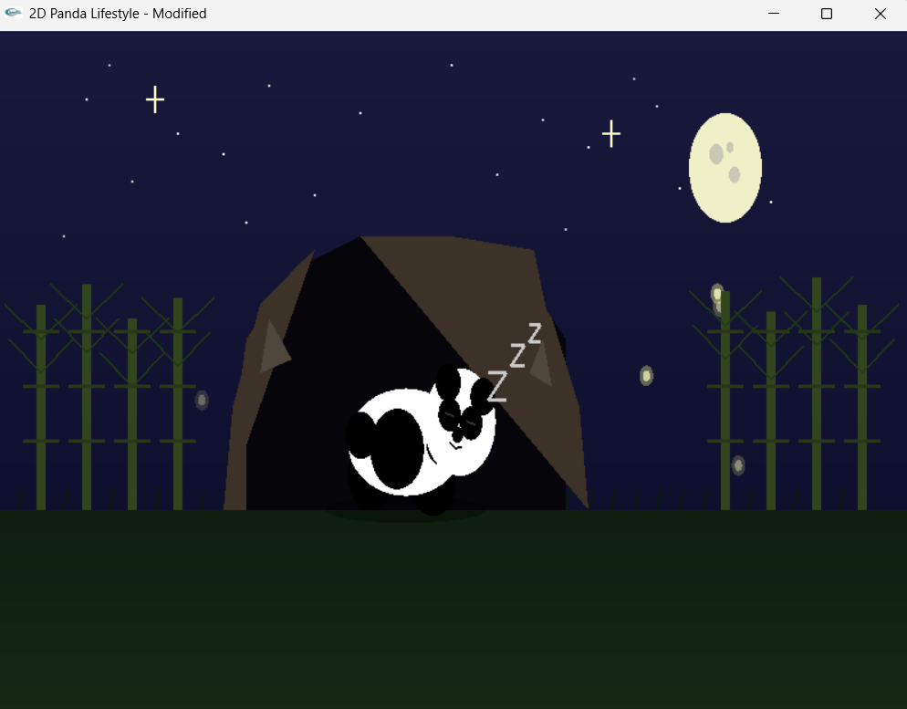

Scene 4: Rolling on Hills (Day View)
Description: In the most playful scene, the panda can roll toward a bamboo forest on the right side of the screen. When activated with the spacebar, the panda rolls joyfully across rolling hills toward the bamboo. Butterflies flutter with animated wings, and motion lines emphasize the panda's movement. The rolling can be started using reset button and paused using the spacebar, and the panda stops when it reaches the bamboo forest.
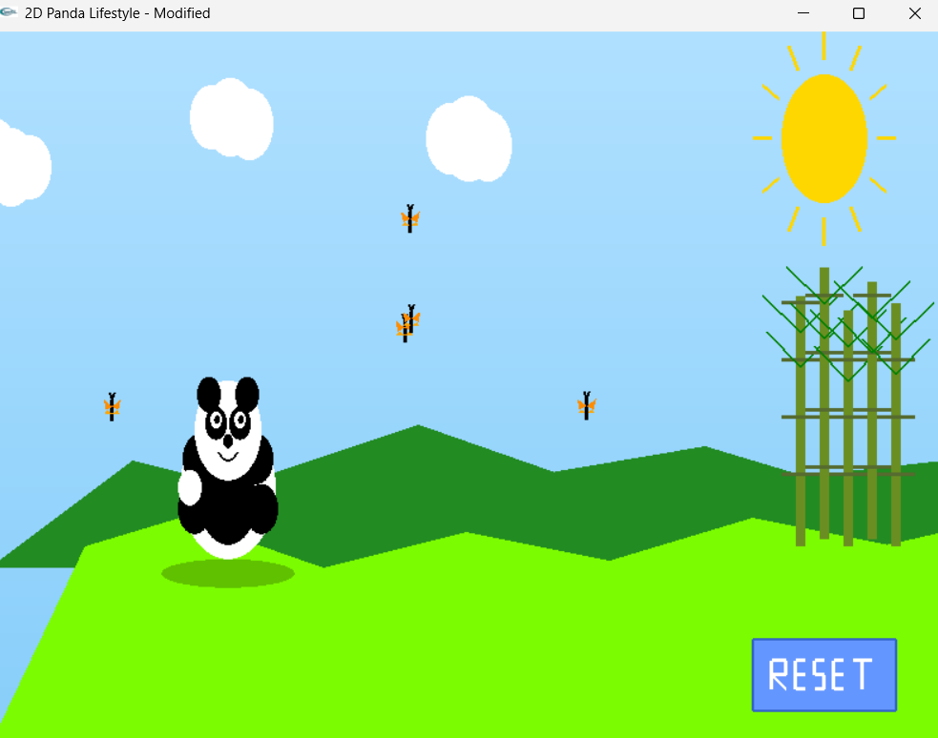

Code Availability
GitHub link: https://github.com/Sumaiya-Raisha/2D-Panda-Lifestyle-Animation

Future work
The project “A Day in the Life of a Panda: Interactive 2D Animation System” demonstrates a strong practical understanding of fundamental computer graphics concepts using OpenGL and GLUT. The project is limited to 2D graphics only. The project has strong potential for expansion. The following future enhancements can significantly increase functionality, realism, and usability:
1. Advanced Interaction Features
2. Sound and Audio Integration
3. Artificial Intelligence (AI) Behavior
4. More Scenes and Story Expansion
5. Transition to 3D Graphics
6. Performance and Visual Enhancements
7. Educational and Real-World Applications
8. Cross-Platform and Modern Framework Support
This project serves as a strong foundation for advanced graphics programming. With added interactivity, intelligence, audio, and possibly 3D rendering, it can evolve from an academic assignment into a fully interactive animated application or game prototype.

Conclusion

The project successfully met all objectives and demonstrates comprehensive understanding of 2D computer graphics principles. The panda animation system is fully functional, visually appealing, and provides an engaging interactive experience. The modular code structure makes it easy to maintain and extend.
The implementation showcases practical application of computer graphics concepts including primitive rendering, transformations, animations, and user interaction. The project serves as an excellent foundation for more advanced graphics programming and demonstrates the creative possibilities of OpenGL.

